**README file**

To run the project, extract all the files from the project.zip folder.

Install the MAMP or WAMP server into the system, from, <http://downloads10.mamp.info/MAMP-PRO-WINDOWS/releases/3.2.2/MAMP_MAMP_PRO_3.2.2.exe> for Mac   
and <http://downloads2.mamp.info/MAMP-PRO-WINDOWS/releases/3.2.2/MAMP_MAMP_PRO_3.2.2.exe> for Windows.

Copy all the files into the folder htdocs of corresponding MAMP application folder.

Go to the phpMyadmin page by entering <http://localhost:8888/MAMP/index.php?page=phpmyadmin&language=English> in the browser of your choice.

Import the music.sql file from the project folder into phpMyadmin. For instructions on this, you can refer to <https://www.godaddy.com/help/import-sql-files-into-mysql-databases-6802>

Run the firstPageSorted2.php file on the browser of your choice.

The home page looks like figure below:

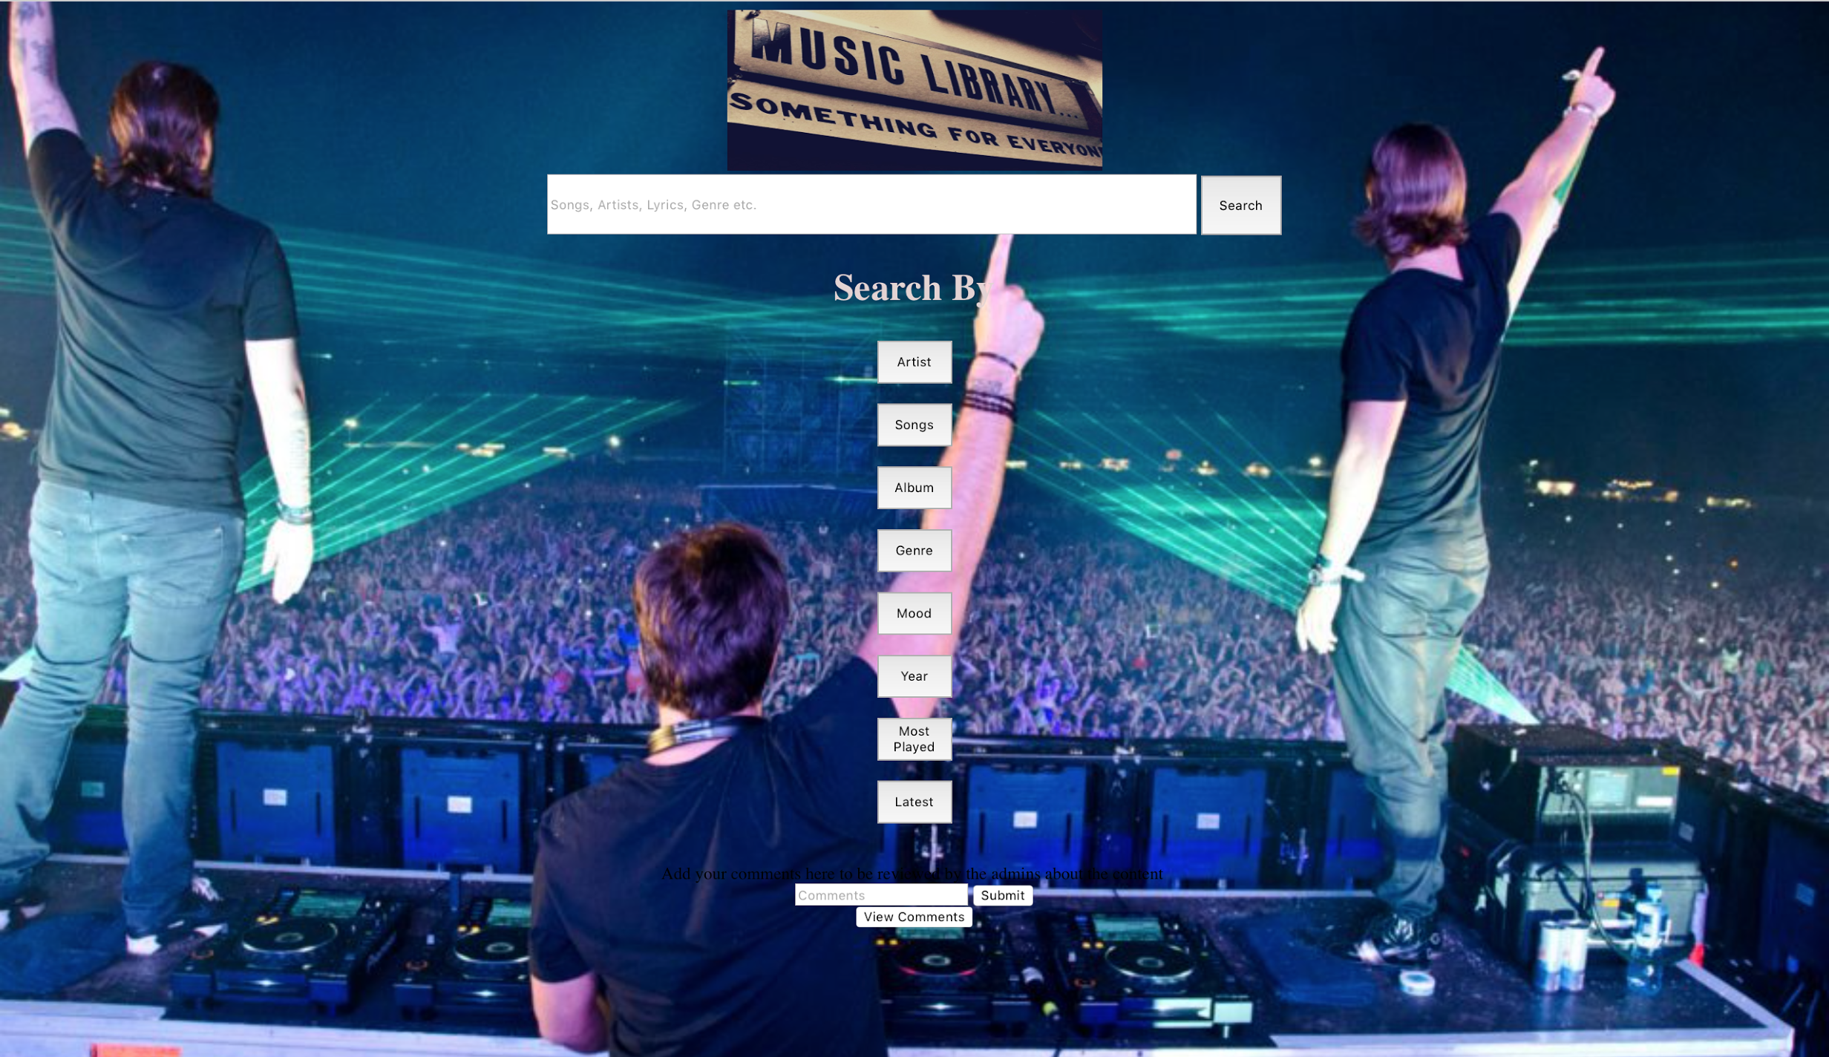

On entering the name of the song in the Search Bar, returns related results. Suppose you heard a song somewhere and don’t know the exact name of it then enter the part which you remember or you can enter anything like artist, genre, album name etc.

Suppose you want to play a song which has the lyric, “Somewhere”, you can just enter it and hit search. Then you will get a page as below,



The result returns list of songs which has the word, “Somewhere” in the song.

The homepage has features to search based on different categories such as Artists, Albums, Genre, Mood, Most Played Songs and Latest.

You can click on Artist to search by Artist names.  
Suppose, you want to search all songs of “David Guetta”, click on Artist button and enter “david” and hit search button.



This query returns the all the songs in the website of David Guetta.



You can play the song of you like according to your interest or depending on the details of the song.

In the same way, you can search for every Category such as Artist, Albums, Genre, Mood, Most Played and Latest